Chapter 5, Solution 57.

Let v₁ be the output of the first op amp and v₂ be the output of the second op amp.

The first stage is an inverting amplifier.
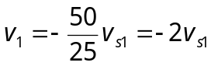
The second state is a summer.

v₂ = –(100/50)v_{s2} – (100/100)v₁ = –2v_{s2} + 2v_{s1}

The third state is a noninverting amplifier

